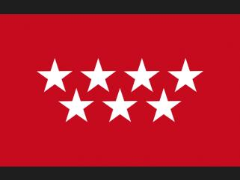

Hello we are from SPAIN
My autonomous community is called Madrid and it une probinces the capital is Madrid the municipality where y live is called Madrid in my autonomous community we speak one language

